3.9 Lagrange Multipliers

In the last section we looked at finding maximums/minimums of functions of two variables. In this section we are interested in working maximizing/minimizing functions under a given constraint. This section is analogous to the topic of optimization from Calculus I.

Motivation:
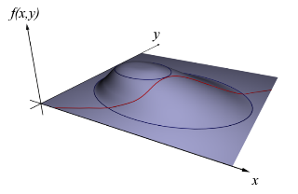
Suppose a company makes x units of item A and y units of item B. Suppose also that their profit is given by the function . If the company must make exactly 10,000 total units (that is we must have ) how many units of item A and B should it make to maximize its profit?

Questions of the above form are the focus of this section. One may correctly notice that the above question can be solved with the techniques of calculus one. However, if our profit function is made up of more than two variables we need a more powerful technique.

We know that forms a surface in 3 space and forms another surface (cutting up from the xy-plane along the line ). The intersection of the two forms a path along the surface (similar to the image above).

So, if we draw some level curves for (shown above in 3D, or below in the 2D xy-plane), it is clearly the case that when the maximum of subject to occurs the path brushes against some specific level curve of .

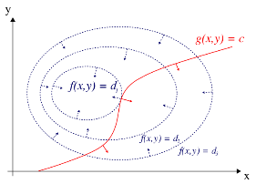
Recall that the gradient has a property that it points perpendicular to the surface/curve for which it is associated. Therefore, we can determine where this “brushing up against” occurs by looking at when the gradients of the level curves are parallel to the gradients of the constraint surface.

We show this more formally on the next page:

Let’s take a closer look at problems of the form: Find the extreme values of subject to a constraint of the form (in hopes of being able to generalize to more variables). We know that forms a surface in 3 space and forms a curve in two space. We will assume is differentiable. So, if we draw some level curve for along with the curve for , we get a picture like:


In the picture it appears that the maximum of subject to is and it occurs at the point highlighted in black.

Suppose we call the point in black . Suppose that the curve given by has a smooth parameterization:

Now, consider (the idea behind the function h is that we input a point on into ).

By the chain rule we know that .

We also know from our discussion of gradient that is orthogonal to the line tangent to the curve determined by at .

So, as long as , there is a constant such that

This idea generalizes in higher dimensions and is the main idea behind Lagrange multipliers. We now formally introduce Lagrange multipliers.
Theorem (Method of Lagrange Multipliers):
To find the maximum and minimum values of subject to the constraint (assuming that these extreme values exist and on the surface ):
- Find all values of x, y, z, and such that and .
- Evaluate at all the points that result from step 1. The largest of these values is the maximum value of ; the smallest is the minimum value of .

Note: To find the extreme values of subject to the constraint , we look for values of x, y, and such that and .

Note: If there is only one solution from 1, one may have to test some points to determine whether it is a max or min.

Note: For the method of Lagrange multipliers (as is stated above) we need to assume that the extreme value(s) of interest exists. This will require us to ensure at the conclusion of a problem that our answer(s) make sense. If one wanted to be quite rigorous in using Lagrange multipliers, one would have to give a proof (using other techniques) that the values found in step two are indeed extrema. Since these proof techniques are beyond the scope of our course we will take a more intuitive approach.

Example 1: Find the extreme values of the function on the circle .

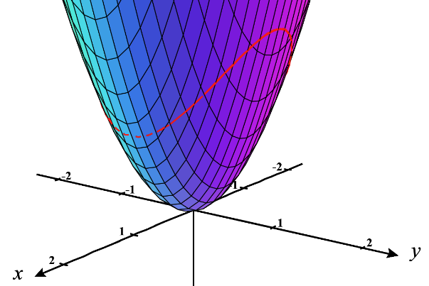

Note: The method of Lagrange Multipliers requires you to solve systems of nonlinear equations. Sadly, there is no algorithmic way to do this (unlike with systems of linear equations, which can always be reduced through elimination/substitution). Some nonlinear equations don’t even have a closed expression for their solutions sets, although we will not be dealing with problems like that in this class.

Nonetheless, one may have to be creative when looking for a solution or setting up a problem to avoid creating a tangled mess of equations. The next example illustrates how an adjustment to our setup, or a creative step in our solution, can be highly impactful on our productivity through the problem.

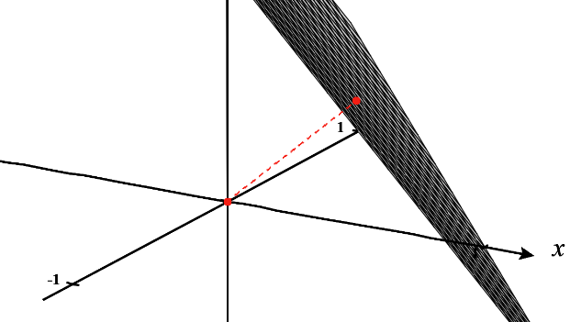
Example 2: Use Lagrange Multipliers to find the shortest distance from the origin to the plane .

Example 3: In section 3.8 we tried to find the minimum and maximum value of over the rectangle region .
- Why doesn’t the method of Lagrange Multipliers help fully answer this question?

- Why is the method of Lagrange Multipliers not optimal for checking for minimums and maximums along the boundary of D?

Note: It is important to understand the difference between finding minimums and maximums over closed and bounded sets and the method of Lagrange Multipliers. Although a question may not state directly to use Lagrange Multipliers we have to be able to understand if this technique or the techniques of section 3.8 are required.

Note: Example 1 from this section could have also been completed using the techniques from section 3.8 of finding absolute minimums and maximums on a closed and bounded set, although we would only be checking the boundary of the region determined by the circle and not the full region.

Example 4: Find the maximum and minimum values of subject to the constraint .
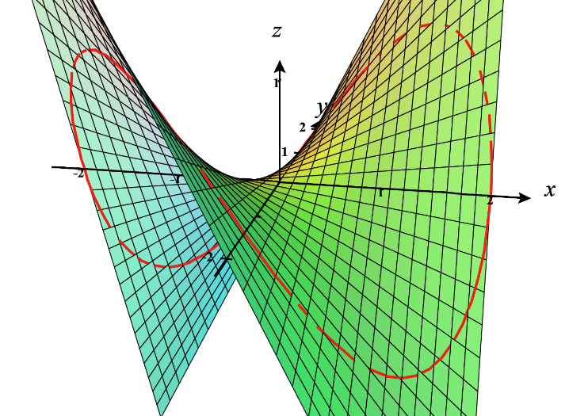

Note: The method of section 3.8 here could be used here to check along the boundary of the region determined by the constraint curve, however this will be more difficult to set up than using Lagrange Multipliers here due to the nature of the functions/equations in this example.
Sometimes the process of solving systems of non-linear equations requires that we take our time, try to organize our work, and systematically work through the possibilities for each implication of our system. The next example demonstrates this.

Example 5: Suppose that a rectangular box without a lid is to be made from of cardboard. Find the maximum volume of such a box.

